Xidian University & Heriot-Watt University

**Artificial Transmission Lines**

(B39HF | B31HD)

High Frequency Circuit Design

**Artificial Transmission Lines**

1. **INTRODUCTION**

The purpose of this experiment is to construct an artificial transmission line composed of 15 cells, and to analyze the corresponding time series waveform and other parameters by changing its specific parameter values, such as generator frequency, shape of generator source, capacitance and inductance values and to explain it by the corresponding transmission line formula.

(1)

In order to match the impedance, we need .

If , the load impedance is .

(2) and (3)

The phase constant β is .

(4)

Convert rads/cell into degrees/cell

(5)

Convert this equation in the form of T

(7)

(6)

A low-loss transmission line can be considered to satisfy and

(8)

By simplification

1. **Lab Activity and Results**
2. Define a 10kHz sine-wave signal from an AC source.

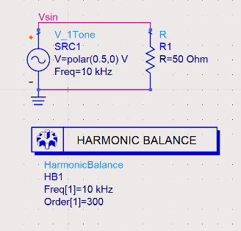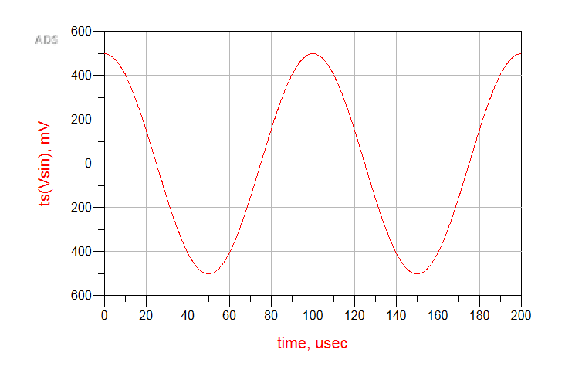

Figure 1. AC Source and Generator Waveform

From the figure we can see that the period of the generator is .

Therefore, its period is .

1. Define an artificial transmission line with 15 cells (15 470-μH inductors in series and 15 shunt 100 pF capacitors).

Figure 2. artificial transmission line with 15 cells

1. According to the Eq.(3), we can get the characteristic impedance:

Therefore, the characteristic impedance is 2167.95 ohms, and to meet the impedance matching, the load impedance is 2167.95 ohms.

1. 图表, 折线图

   描述已自动生成From Figure3, we can see that the signal source is the same as Lab Activity 1.

Figure 3. Input and Output Signal Waveforms

We can see from the figure that the input signal and the output signal are basically the same, but there is a certain phase difference between the two waveforms.

1. According to Eq.(2), we can get:

That means 10kHz satisfies Eq.(2).

1. According to Figure 4, we can find that the phase difference between the input and output is 11.723°. And the output is lagging with respect to the input terminal.

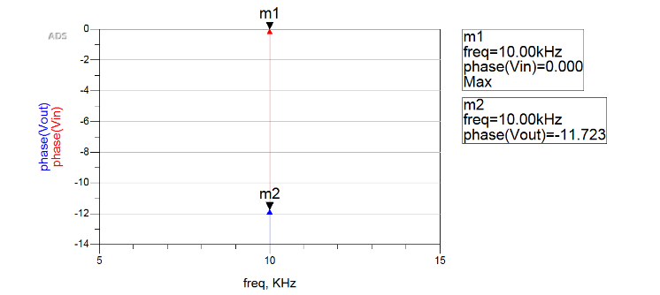

Figure 4. Phase Difference between the Input and Output

In theory, the phase difference between input and output is:

Compare the theoretical value (11.707°) with the simulated value (11.723°), we know that the simulation results and theoretical results are equal within the allowed error range.

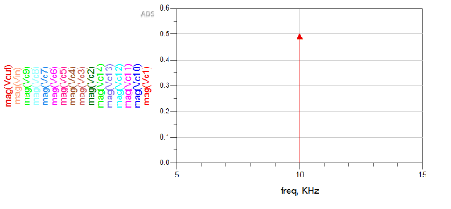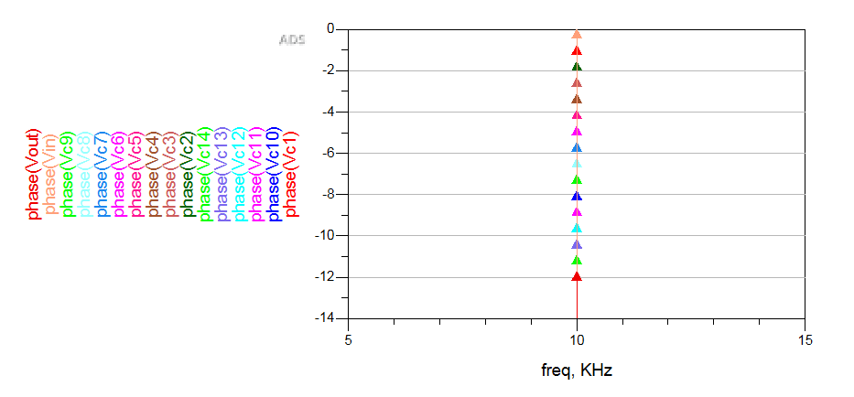

Figure 5. Amplitude and Phase Difference at every Junction

According to Figure 5, we can get the table below:

Table 1. Amplitude and Phase Difference at every Junction

|  |  |  |  |  |
| --- | --- | --- | --- | --- |
| Junction | Simulated value | | Theoretical value | |
| Amplitude | Phase (degree) | Amplitude | Phase (degree) |
| Input | 0 | 0 | 0 | 0 |
| Cell 1 | 0 | 0.783 | 0 | 0.781 |
| Cell 2 | 0 | 1.563 | 0 | 1.561 |
| Cell 3 | 0 | 2.347 | 0 | 2.340 |
| Cell 4 | 0 | 3.129 | 0 | 3.122 |
| Cell 5 | 0 | 3.911 | 0 | 3.902 |
| Cell 6 | 0 | 4.693 | 0 | 4.683 |
| Cell 7 | 0 | 5.475 | 0 | 5.463 |
| Cell 8 | 0 | 6.256 | 0 | 6.244 |
| Cell 9 | 0 | 7.038 | 0 | 7.024 |
| Cell 10 | 0 | 7.819 | 0 | 7.805 |
| Cell 11 | 0 | 8.600 | 0 | 8.585 |
| Cell 12 | 0 | 9.381 | 0 | 9.366 |
| Cell 13 | 0 | 10.162 | 0 | 10.146 |
| Cell 14 | 0 | 10.934 | 0 | 10.926 |
| Cell 15(Output) | 0 | 11.723 | 0 | 11.707 |

Using Table 1, we can easily compare the amplitude and phase differences between the theoretical and simulated values.

For the amplitude difference, we can see that the amplitude difference (relative to zero) at each node is 0, because there are no resistors and inductors in the transmission line. This satisfies our theoretical calculations very well.

For the phase difference, we can see that the theoretical value is basically consistent with the simulated value, and the relationship is linear with the increase of cells. This is also basically consistent with the theory.

1. 图表

   描述已自动生成

Figure 6. Waveform for Each Cell

According to Figure 6, The simulation value of the time delay for each cell is 0.25 usec.

According to Eq.(6), the theoretical value of the time delay for each cell is:

Comparing the theoretical value with the simulation value, we can see that the two are basically equal, and the total time delay will increase linearly with the increase of the cell.

1. 图形用户界面

   中度可信度描述已自动生成Define an artificial transmission line with 15 cells (15 470-μH inductors in series and 15 shunt 1-nF capacitors).

Figure 7. artificial transmission line with 15 cells

1. According to the Eq.(3), we can get the characteristic impedance:

Therefore, the characteristic impedance is 685.57 ohms, and to meet the impedance matching, the load impedance is 685.57 ohms.

1. From Figure8, we can see that the signal source is the same as Lab Activity 1.
2. We can see from the figure that the input signal and the output signal are basically the same, but there is a certain phase difference between the two waveforms.

Figure 8. Input and Output Signal Waveforms

1. According to Eq.(2), we can get:

That means 10kHz satisfies Eq.(2).

1. According to Figure 9, we can find that the phase difference between the input and output is 37.482°. And the output is lagging with respect to the input terminal.

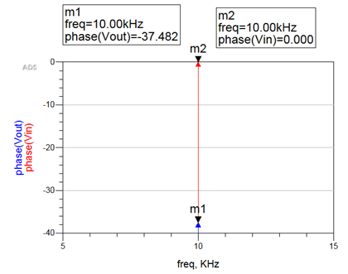

Figure 9. Phase Difference between the Input and Output

In theory, the phase difference between input and output is:

Compare the theoretical value (37.482°) with the simulated value (37.02°), we know that the simulation results and theoretical results are equal within the allowed error range.

1. 图片包含 图表

   描述已自动生成

Figure 10. Amplitude and Phase Difference at every Junction

According to Figure 10, we can get the table below:

Table 2. Amplitude and Phase Difference at every Junction

|  |  |  |  |  |
| --- | --- | --- | --- | --- |
| Junction | Simulated value | | Theoretical value | |
| Amplitude | Phase (degree) | Amplitude | Phase (degree) |
| Input | 0 | 0 | 0 | 0 |
| Cell 1 | 0 | 2.495 | 0 | 2.468 |
| Cell 2 | 0 | 4.99 | 0 | 4.936 |
| Cell 3 | 0 | 7.485 | 0 | 7.404 |
| Cell 4 | 0 | 9.98 | 0 | 9.872 |
| Cell 5 | 0 | 12.475 | 0 | 12.34 |
| Cell 6 | 0 | 14.97 | 0 | 14.808 |
| Cell 7 | 0 | 17.465 | 0 | 17.276 |
| Cell 8 | 0 | 19.96 | 0 | 19.744 |
| Cell 9 | 0 | 22.455 | 0 | 22.212 |
| Cell 10 | 0 | 24.95 | 0 | 24.68 |
| Cell 11 | 0 | 27.445 | 0 | 27.148 |
| Cell 12 | 0 | 29.94 | 0 | 29.616 |
| Cell 13 | 0 | 32.435 | 0 | 32.084 |
| Cell 14 | 0 | 34.93 | 0 | 34.552 |
| Cell 15(Output) | 0 | 37.482 | 0 | 37.02 |

1. 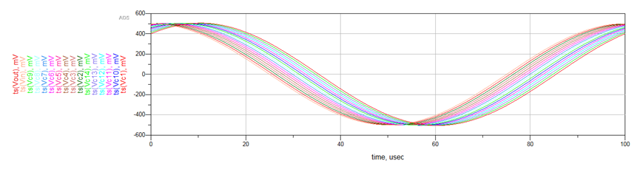

Figure 11. Waveform for Each Cell

According to Figure 6, The simulation value of the time delay for each cell is 0.66 usec.

According to Eq.(6), the theoretical value of the time delay for each cell is:

Comparing the theoretical value with the simulation value, we can see that the two are basically equal, and the total time delay will increase linearly with the increase of the cell.

1. 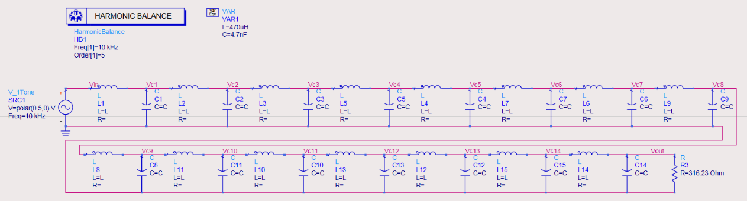Define an artificial transmission line with 15 cells (15 470-μH inductors in series and 15 shunt 4.7-nF capacitors).

Figure 12. artificial transmission line with 15 cells

1. According to the Eq.(3), we can get the characteristic impedance:

Therefore, the characteristic impedance is 316.23 ohms, and to meet the impedance matching, the load impedance is 316.23 ohms.

1. From Figure3, we can see that the signal source is the same as Lab Activity 1.
2. We can see from the figure that the input signal and the output signal are basically the same, but there is a certain phase difference between the two waveforms.

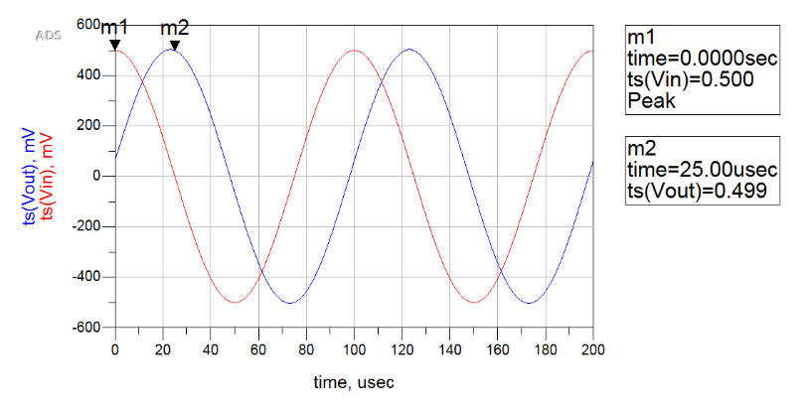

Figure 13. Input and Output Signal Waveforms

1. According to Eq.(2), we can get:

That means 10kHz satisfies Eq.(2).

1. According to Figure 14, we can find that the phase difference between the input and output is 82.916°. And the output is lagging with respect to the input terminal.

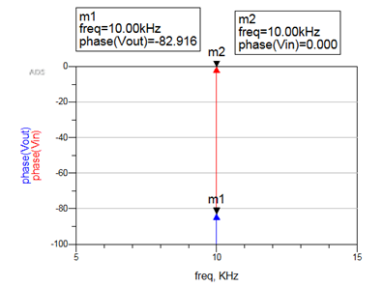

Figure 14. Phase Difference between the Input and Output

In theory, the phase difference between input and output is:

Compare the theoretical value (82.916°) with the simulated value (80.26°), we know that the simulation results and theoretical results are equal within the allowed error range.

1. 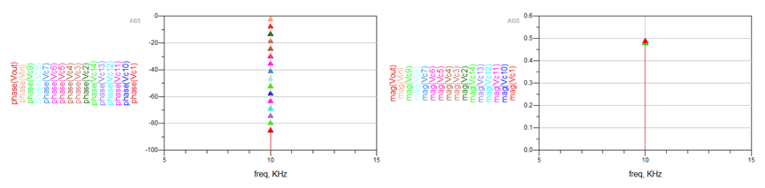

Figure 15. Amplitude and Phase Difference at every Junction

According to Figure 15, we can get the table below:

Table 3. Amplitude and Phase Difference at every Junction

|  |  |  |  |  |
| --- | --- | --- | --- | --- |
| Junction | Simulated value | | Theoretical value | |
| Amplitude | Phase (degree) | Amplitude | Phase (degree) |
| Input | 0 | 0 | 0 | 0 |
| Cell 1 | 0 | 5.528 | 0 | 5.351 |
| Cell 2 | 0 | 11.056 | 0 | 10.702 |
| Cell 3 | 0 | 16.584 | 0 | 16.053 |
| Cell 4 | 0 | 22.112 | 0 | 21.404 |
| Cell 5 | 0 | 27.64 | 0 | 26.755 |
| Cell 6 | 0 | 33.168 | 0 | 32.106 |
| Cell 7 | 0 | 38.696 | 0 | 37.457 |
| Cell 8 | 0 | 44.224 | 0 | 42.808 |
| Cell 9 | 0 | 49.752 | 0 | 48.159 |
| Cell 10 | 0 | 55.28 | 0 | 53.51 |
| Cell 11 | 0 | 60.808 | 0 | 58.861 |
| Cell 12 | 0 | 66.336 | 0 | 64.212 |
| Cell 13 | 0 | 71.864 | 0 | 69.563 |
| Cell 14 | 0 | 77.392 | 0 | 74.914 |
| Cell 15(Output) | 0 | 82.916 | 0 | 80.26 |

1. 图表, 直方图

   描述已自动生成

Figure 16. Waveform for Each Cell

According to Figure 6, The simulation value of the time delay for each cell is 1.5 usec.

According to Eq.(6), the theoretical value of the time delay for each cell is:

Comparing the theoretical value with the simulation value, we can see that the two are basically equal, and the total time delay will increase linearly with the increase of the cell.

1. The transmission line will cause square wave distortion, resulting in the simulation output cannot display the corresponding input waveform. Square waves are composed of many sinusoidal waves of different frequencies, and the sinusoidal wave components of different frequencies propagate at different speeds along the transmission line. Therefore, after the matrix wave passes through the equivalent transmission line, the waveform will be deformed.

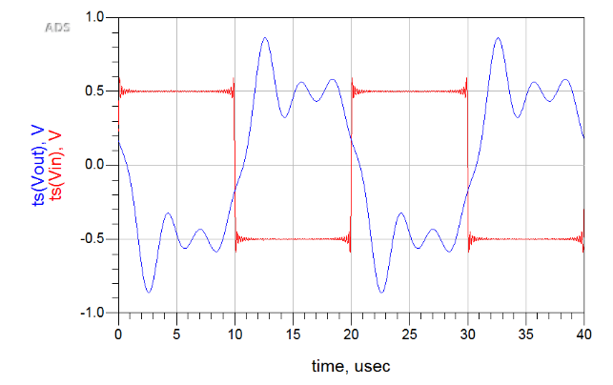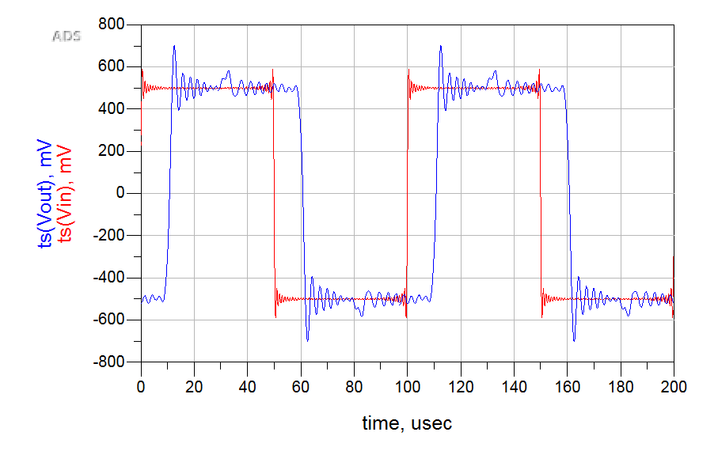

Figure18. the Input and Output Waveforms of 50kHz Square Wave

Figure17. the Input and Output Waveforms of 10kHz Square Wave

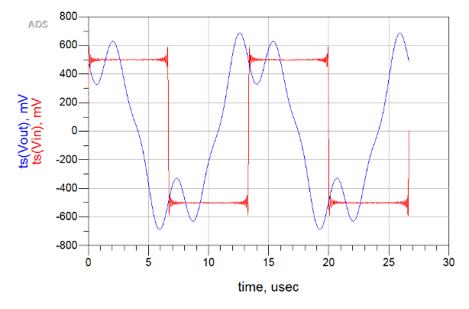

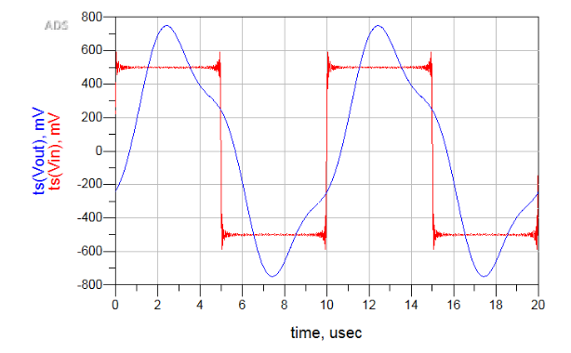

Figure20. the Input and Output Waveforms of 100kHz Square Wave

Figure19. the Input and Output Waveforms of 75kHz Square Wave

From the above four frequencies, when the signal source is a matrix square wave and the frequency increases, the output signal gradually approaches a sine wave. At 10kHz, we can see that the output waveform is basically the same as the square wave. However, as the frequency continues to increase, the output waveform gradually becomes distorted and approaches the sine wave. The reason is mainly because the square wave is composed of sine waves with different frequencies. As the frequency continues to increase, higher harmonics cannot pass through the inductor, and the final output signal will be presented as a sine wave.

1. Redefine a 100 kHz sine-wave signal as the generator.
2. Build the transmission line according to the experimental requirements.

图示

Figure 21. Transmission Line Cells in ADS Simulation

1. At frequency 100kHz, the characteristic impedance of this lossy transmission line is:

However, According to Eq.(7).

We can find that the low-loss conditions are satisfied at 100kHz. So, we can treat it as lossless circuit.

1. Because at 100kHz, the transmission line meets the low loss condition. The characteristic impedance is:
2. Impedance matching needs to meet the load and characteristic impedance equal. Therefore, the load is: .

Figure 22. Artificial Transmission Line with 15 Cells

1. 图形用户界面, 图表

   描述已自动生成

Figure 23. Amplitude and Phase Difference between the Input and Output Waveform for 100kHz

According to Figure 23, we can see that the simulation value of the amplitude difference is 0.06V and the simulation value of the phase difference is 119.802°.

According to Eq.(8),

Therefore, the theoretical values of the amplitude and phase difference are:

By comparing the theoretical value with the actual value, we can see that the phase difference is basically the same, while the amplitude difference has a small error.

The error analysis is:

1. The signal is distorted during transmission. We can see from Figure 24 that the amplitude of the output signal is different from the amplitude of the input signal, that is, the amplitude of the signal is attenuated.

Figure 24. Amplitude and Phase Difference between the Input and Output Waveform for 10kHz

**For 10 kHz:**

According to the figure 24, we can see that the simulation value of the amplitude difference is 0.039V and the simulation value of the phase difference is 11.761°

Time delay :

The simulated time delay is: .

The theoretical time delay is: .

Voltage amplitude :

The theoretical voltage amplitude difference is: .

The simulated voltage amplitude difference is: .

**For 100 kHz:**

According to the figure 23, we can see that the simulation value of the amplitude difference is 0.06V and the simulation value of the phase difference is 119.802°.

Time delay :

The simulated time delay is: .

The theoretical time delay is: .

Voltage amplitude :

The theoretical voltage amplitude difference is: .

The simulated voltage amplitude difference is: .

By comparing the results of 10kHz and 100kHz, we can see that the change of frequency does not lead to a change in amplitude. However, the factor that really determines the amplitude is the loss constant α.

1. Discussion
2. **Reference**

[1] <https://blog.csdn.net/yinuoheqian123/article/details/130840375>

[2] B39HF-B31HD Laboratory 1 - Artificial Transmission Lines (final)

**Appendix**

Pre-Lab Assignment

Q1.Solution:

We need to make sure that .

Therefore

Which is

The upper frequency limit is

Q2.Solution:

Characteristic impedance

Phase shift

Time delay

Q3.Solution:

Characteristic impedance

Phase constant

Graphs below:

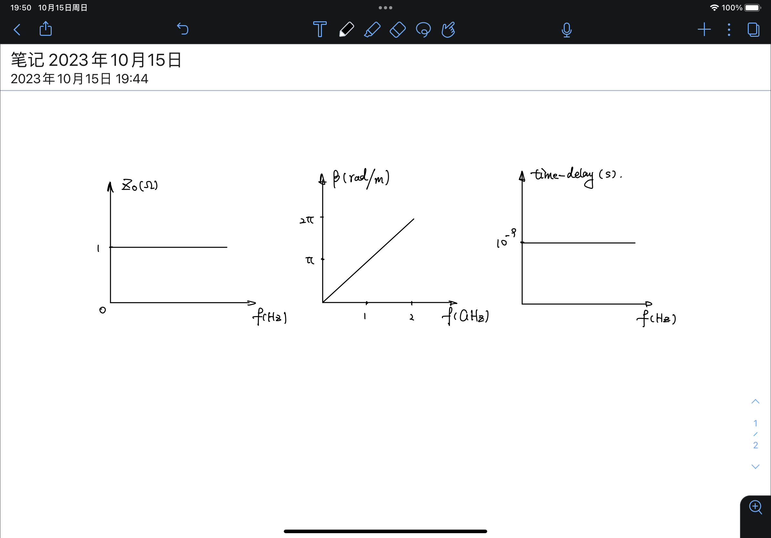

Discussion:

Characteristic impedance and time delay are independent from frequency.

Phase constant is linearly related to the frequency with a slope of .

Q4.Solution:

Therefore